First name and last name of the presenting author:
Francisco J. Navarro-Meneses

Email address:
fnavarro@nebrija.es

Presenting author’s country:
Spain

Affiliation (University / Institution):
Nebrija University

Would you like to submit your paper to any of the associated journals? (Substitute the square for an X):
X Journal of Policy Research in Tourism, Leisure and Events (scope: public policies to manage the economic, social, and environmental impacts of business and events tourism—MICE).
◻ Revista Brasileira de Pesquisa em Turismo (RBTUR) (other topics of interest to the journal).
◻ No, I do not wish to submit my paper to any journal.

This page, with all fields completed, must be included before the abstract.
Below is the template that must be used to prepare your abstract.

Rethinking the Analytical Foundations of Tourism Systems Research: An Emergence–Diffusion Framework for Policymaking

Navarro-Meneses, Francisco J.¹

¹. Faculty of Economics and Business, Nebrija University [Presenting author]

Abstract
Tourism research increasingly recognizes the complex, adaptive, and interconnected nature of tourism systems, yet many analytical approaches remain centered on identifying relationships among variables and estimating bounded effects. Although valuable, these approaches do not by themsleves explain how interactions generate system-level configurations, how these configurations evolve, or how their consequences propagate through interconnected components and settings. This paper develops an emergence–diffusion framework to advance the analytical foundations of tourism systems research. Drawing on complexity science, relational and processual conceptions of emergence, and diffusion theory, the framework conceptualizes emergence and diffusion as recursively interconnected processes through which tourism-system configurations are generated, sustained, and transformed. It provides an analytical basis for investigating the interactions and feedback mechanisms underlying emergent configurations, their influence on subsequent behavior, and the pathways through which pressures, practices, and responses propagate and change. An illustrative application to overtourism demonstrates how the framework can inform the investigation of systemic pressures, their diffusion within a destination, and the adaptive and distributional consequences of policy interventions. The paper further discusses its analytical contributions and implications for anticipatory and adaptive policymaking. By integrating the generative and diffusive dynamics of tourism systems, the proposed framework complements established analytical approaches and broadens the capacity to explain systemic evolution and transformation.

Keywords: Tourism Systems; Emergence; Diffusion; Complexity Science; Causal Inference; Overtourism; Tourism Policymaking.

Introduction

Tourism research has become increasingly methodologically sophisticated. Contemporary empirical studies make extensive use of regression-based models, structural equation modelling, and related multivariate and econometric techniques. These methods have strengthened the field’s capacities for description, prediction, and evaluation (Ali et al., 2021; Nunkoo et al., 2013; Song et al., 2019) . Yet methodological sophistication does not necessarily entail analytical adequacy, nor does it by itself generate deeper or more comprehensive causal knowledge of the phenomena under investigation.

This limitation is particularly relevant because many key tourism phenomena arise within open, complex, adaptive systems. Outcomes such as congestion, resident opposition, environmental stress, or institutional change develop through historically conditioned interactions among heterogeneous actors and structures across spatial and temporal scales. Because these interactions are interdependent and shaped by reinforcing and balancing feedback, their collective effects may differ qualitatively from the additive effects of isolated factors. A fundamental tension therefore persists between the systemic character of tourism phenomena and the analytical foundations of much tourism research.

Approaches designed to isolate variables and estimate specified relationships may identify associations or effects under stated conditions, but they are less able to explain how system-level configurations emerge, evolve, and propagate consequences across connected contexts. Nevertheless, much tourism research remains organized around variables and directional relationships. This orientation is not problematic in itself. Causal claims become defensible when a study clearly identifies the proposed cause and outcome, establishes that the cause precedes the outcome, specifies the intervention or condition being examined, and adequately addresses plausible alternative explanations. The problem arises when association, model fit, predictive performance, or directional paths are presented as evidence of causation without a research design capable of supporting that inference.

Modern causal inference makes clear that causal conclusions do not follow from statistical technique alone. They require a clearly specified causal question, a defensible ordering of cause and outcome, and a research design capable of distinguishing the effect from plausible alternative explanations (Hernán & Robins, 2026; Pearl, 2009). Significant coefficients or well-fitting models may be compatible with a causal explanation, but they do not establish one.

Even credible causal estimates address only part of the problem. They concern a defined intervention under specified conditions, and the estimated effect may change when policy alters those conditions and actors adapt. For instance, estimating the effect of a tourist tax, rental regulation, or a mobility restriction does not explain how destination stress emerges, how actors reorganize, or how consequences spread across connected settings. Causal inference can estimate the effects of specified interventions under appropriate identification assumptions, but such estimates do not explain the endogenous formation and transformation of the tourism system in which those interventions occur.

Complexity-oriented tourism scholarship has recognized destinations as complex adaptive systems characterized by nonlinearity, self-organization, co-evolution, feedback, path dependence, and porous boundaries (Baggio, 2008; Farrell & Twining-Ward, 2004; McKercher, 1999). In some applications, however, complexity concepts remain primarily interpretive, while analytical methods are employed without sufficiently specifying their explanatory functions. Despite important advances in complexity-oriented tourism research, further integration is needed to connect the generation of system-level configurations, the propagation of their consequences, and the analysis of policy interventions.

To address this gap, the paper proposes an emergence–diffusion framework for tourism systems research. Emergence explains how interactions among heterogeneous components generate system-level configurations that cannot be adequately reduced to the effects of those components considered separately (Chalmers, 2006; Green, 2023; Rosas et al., 2020). Diffusion explains how behaviors, practices, information, and policy responses propagate through spatial, organizational, market, and institutional connections, with their transmission and consequences shaped by the receiving contexts (Ansari et al., 2010; Rogers et al., 2014; Shipan & Volden, 2008). The two processes are recursive: emergent configurations create conditions for propagation, while diffusing elements are transformed by receiving contexts and may contribute to the formation of new configurations.

Against this background, the paper asks: How can tourism systems research explain the emergence and diffusion of system-level phenomena within and across interconnected tourism systems, and how can these explanations inform tourism policy analysis and evaluation? The answer developed in this paper rests on four interrelated contributions. It first distinguishes legitimate causal inference from causal vocabulary unsupported by identification. It then develops a relational and processual account of emergence and connects it to diffusion through a three-level framework of local interaction, system configuration, and cross-system propagation. Finally, it aligns this framework with a provisional methodological architecture that combines causal, computational, relational, longitudinal, and process evidence.

Overtourism provides an illustration. Rather than treating it as a direct effect of visitor numbers, the paper conceptualizes destination stress as a configuration produced by the interaction of visitor flows with spatial, environmental, social, infrastructural, and governance conditions. Once formed, this configuration may propagate through displacement, imitation, investment, policy transfer, and changing visibility. The example shows why policy research must examine not only whether an intervention produces a local effect, but also how that effect persists, adapts, moves, and transforms within the wider system.

The remainder of the paper is organized as follows. It begins by examining the foundations of causal explanation and emergence, establishing the analytical distinctions motivating the proposed framework. It then develops the emergence–diffusion framework and outlines its operationalization for tourism systems research. An illustrative application to overtourism examines the emergence and diffusion of systemic pressures and their implications for policymaking. The subsequent discussion addresses the framework’s analytical contributions, scope conditions, research and policy implications, and limitations. The paper concludes by synthesizing its principal contributions and implications for advancing tourism systems research.

Causal Explanation and the Foundations of Emergence

The limitations discussed in this paper do not question the value of quantitative methods or causal inference in tourism research. Rather, they concern the interpretation of statistical relationships as causal evidence without sufficient theoretical justification or appropriate research designs. Distinguishing association, prediction, and causal inference is therefore essential, while recognizing that even credible estimates of specified causal effects do not, by themselves, explain how tourism systems emerge, evolve, and transform.

Statistical Modelling and Causal Inference
Tourism studies routinely examine the “drivers”, “determinants”, “antecedents”, “impacts”, or “effects” of observed phenomena. This language reflects a legitimate aspiration to explain why outcomes occur and what might change them. The difficulty is that description, association, prediction, and causal inference are often treated as interchangeable. Description characterizes observed data; association identifies how variables vary together; prediction evaluates whether a model anticipates outcomes in new observations; and causal inference asks what difference a specified intervention or exposure would make relative to a counterfactual alternative. Success in one task does not establish success in another (Pearl, 2009; Shmueli, 2010).

Statistical modelling supports a causal claim only when it is embedded in a design capable of answering a clearly specified causal question. Researchers must define the proposed cause and outcome, establish their temporal order, clarify the intervention or condition being compared, and address plausible alternative explanations. The potential-outcomes tradition formalizes this task by comparing the outcomes that would occur under alternative exposure conditions. Structural causal modelling instead represents assumptions about the process that generates the data and asks what follows when that process is intervened upon. Although the two traditions differ in formal emphasis, both distinguish an observed association from the effect of changing a cause (Cox & Wermuth, 2004).

This requirement is obscured when a method is treated as intrinsically causal. Structural equation modelling (SEM) can represent a theoretically specified causal structure and assess whether observed covariance is compatible with it. Model fit alone cannot determine whether the proposed direction is correct, whether relevant confounders have been omitted, or whether an observationally equivalent structure offers another explanation. SEM is therefore neither inherently causal nor inherently non-causal; its interpretation depends on the assumptions encoded in the model and the design-based reasons for accepting them (Bollen & Pearl, 2013). The same caution applies to regression controls and longitudinal data. Controls can introduce bias when they are consequences of the exposure, mediators, or colliders, while temporal sequence does not automatically remove reciprocal causation, time-varying confounding, anticipation, or attrition.

These problems are especially salient in tourism because many central relationships are reciprocal. Destination image influences visitation, while accumulated visitation reshapes destination image; resident attitudes affect policy, while tourism development and policy alter those attitudes. Similar interdependence connects infrastructure with demand and digital platforms with accommodation supply. A cross-sectional survey may provide valuable evidence about perceptions and covariance, but simultaneous measurement cannot ordinarily establish temporal mediation, adaptation, or behavioral change.

Reviews of SEM applications in tourism have documented the technique’s rapid diffusion alongside weaknesses in model comparison, assumption testing, effect-size reporting, and measurement assessment (Mikulić & Ryan, 2018; Nunkoo et al., 2013). The criticism is not that surveys, latent variables, or structural models lack value. It concerns an escalation of the evidential claim: an associational model is estimated, significant paths are called effects, and interventions are recommended as though their counterfactual consequences had been established.

Causal overreach commonly occurs when a researcher-imposed arrow substitutes for temporal and causal ordering, when model fit is treated as confirmation of a unique causal structure, or when a predictive or associational result is translated directly into a policy lever. The last move is particularly problematic when the predictor cannot be manipulated or when the observed relationship would change under intervention. Comparable caution applies to Granger-causality tests, which establish predictive precedence conditional on a model specification, and to configurational methods, whose sufficient or necessary combinations still require temporal knowledge and a defensible generative account before they support causal interpretation (Shojaie & Fox, 2022).

Machine learning and large-scale digital data do not remove these constraints. They can improve forecasting, reveal heterogeneity, and detect nonlinear relationships, but predictive accuracy alone does not establish the causal effects of interventions (Kleinberg et al., 2015; Mullainathan & Spiess, 2017). Moreover, increasing data volume does not eliminate selection bias or problems of representativeness, while platform-generated data may reflect changing algorithms and historically contingent patterns of behaviour (Lazer et al., 2014; Meng, 2018).

The corrective action is therefore explicit analytical discipline: researchers should state whether the purpose is description, prediction, causal estimation, or systemic explanation; define the causal contrast when claiming an effect; justify the identification strategy; examine rival accounts; and restrict conclusions to what the design can support. When these conditions are met, statistical modelling can provide credible estimates of specified causal effects. The remaining question is what such estimates leave unexplained about the wider tourism system.

Beyond Bounded Causal Effects
Suppose that a study credibly estimates the effect of short-term-rental regulation on housing prices or of an access restriction on congestion. Such evidence is valuable because it answers a defined causal question for a specified population, period, and institutional setting. Its limitation arises when the estimated effect is treated as an explanation of the wider tourism system.

A causal effect is generated within a particular institutional, relational, spatial, and historical configuration. That configuration shapes the response to an intervention and may itself change once the intervention is introduced. Interference is especially important: it occurs when an intervention affecting one unit changes outcomes in another (Hudgens & Halloran, 2008). For example, restricting access to one attraction may redirect visitors elsewhere, while regulating accommodation in one municipality may move supply and investment across its boundaries. In tourism, interference is often a mechanism through which effects propagate rather than merely a statistical complication.

Interventions also change through interpretation and adaptation. A tourist tax, for instance, may be absorbed by firms, passed on to visitors, accompanied by product redesign, or contested politically. Visitors, residents, and public authorities may then adjust their behavior in response. What initially appears to be a single intervention becomes a branching process of interpretation and adaptation (Hawe et al., 2009), whose consequences can extend beyond the jurisdiction in which it originated.

Systemic consequences are also not adequately represented by average effects alone. A moderate average change may conceal a threshold crossed by a particular neighborhood, business segment, or social group. A substantial short-term effect may weaken or reverse as actors adapt, while initially minor consequences may accumulate through feedback. Sequence, persistence, and transformation may therefore matter as much as average magnitude. Systemic explanation must therefore ask how the initial configuration arose, how the intervention reorganized relationships, how and where its consequences propagate, and whether it alters the longer-term trajectory of the system.

The argument is not that causal inference is intrinsically unable to examine heterogeneous effects and dynamic interventions. These problems can be addressed when they are explicitly incorporated into the causal question, research design, and identifying assumptions. The distinction concerns explanatory scope. Causal analysis estimates the consequences of a specified contrast within a defined population and setting; systemic explanation examines how interdependent relationships generate, change, and propagate the configuration within which that contrast operates. The two forms of explanation are therefore complementary, but neither substitutes for the other.

The distinction can be organized around three complementary questions. Effect estimation asks what difference a specified intervention makes to a particular outcome under stated conditions. Emergence asks through which interactions a system-level property comes into existence. Diffusion asks through which spatial, relational, or institutional connections that property and its consequences propagate and change. The emergence–diffusion perspective thus situates credible causal estimates within a broader explanation of how open, multilevel, and adaptive tourism systems form and transform.

Identifying Emergent Properties
Emergence is often described through the proposition that a system is more than the sum of its parts (Holland, 1998). Although suggestive, this formulation is insufficient because not every collective property is emergent. For instance, total visitor numbers, aggregate tourism expenditure, mean hotel occupancy, and average resident satisfaction can be calculated by adding or averaging individual observations. They are aggregate properties, but their existence does not depend on interaction among the units being aggregated.

Emergence implies a stronger relationship between parts and wholes. A property is emergent when it is generated through the organization and interaction of system components. It depends not only on which components are present, but also on how they are connected, how they respond to one another, and how those relationships develop over time (Green, 2023; Rosas et al., 2020). The resulting system-level configuration may display regularities or capacities that belong to no component in isolation and cannot be adequately explained by summing their independent contributions.

This distinction is fundamental for tourism systems research. Phenomena such as congestion, collective resident opposition, institutional legitimacy, resilience, and overtourism may exhibit emergent properties when their development depends on interactions and configurations that cannot be adequately explained through aggregation or independent component effects. Congestion, for example, develops through the interaction of movement patterns, spatial capacity, and users’ behavioral adaptations. Similarly, collective resident opposition may emerge as individuals experience tourism-related pressures, interpret their consequences, and mobilize through social and institutional relationships. Consequently, comparable visitor volumes may generate different outcomes across destinations, or within the same destination over time, depending on how these relationships are organized. Explaining such phenomena therefore requires examining the configurations and interactions through which they develop, rather than treating them as simple aggregates.

Emergence therefore changes the object of explanation. Rather than asking only how much an independent variable changes an outcome, it asks how a configuration comes into existence, acquires coherence, and persists or transforms. Individual actors and variables continue to matter, but their effects depend on the organization of the system in which they operate.

This insight has a long intellectual lineage. Systems theory challenged attempts to explain organized wholes exclusively through decomposition, while complexity science demonstrated how local interactions can generate nonlinear patterns, self-organization, adaptation, and critical transitions. Anderson’s (1972) proposition that “more is different” captured the central implication: changes in system organization may produce regularities that require new explanatory concepts.

Tourism scholarship has similarly conceptualized destinations as evolving systems composed of heterogeneous and interdependent actors (Baggio, 2008). However, emergence is still frequently invoked only to indicate that tourism is complicated or unpredictable. A more rigorous account must specify how interactions generate system-level configurations and how those configurations subsequently condition action—the task developed by the emergence–diffusion framework.

The Emergence–Diffusion Framework for Tourism Systems
The emergence–diffusion framework connects two complementary explanatory processes: the generation of system-level configurations through interaction and the propagation and contextual transformation of their patterns and consequences. Their recursive relationship provides a basis for analyzing tourism systems as relational, historically evolving, and open.

Relational and Temporal Emergence
Building on the distinction between emergent and aggregate properties, the framework conceptualizes emergence as a relational and temporal process through which interactions generate system-level configurations that condition subsequent behavior and evolve through feedback and adaptation. Philosophical accounts distinguish weak emergence, in which macro-patterns arise from lower-level interactions but may be derivable only through simulation, from strong emergence, which attributes irreducible causal powers to macro-properties (Bedau, 2002; Chalmers, 2006). Tourism systems research does not require the stronger metaphysical claim. Instead, it adopts a relational and processual perspective in which system-level properties depend on the organization of components while shaping the conditions under which subsequent interactions occur.

Emergent configurations acquire explanatory significance through the constraints, opportunities, and expectations they generate, without operating independently of their constituent relationships. Destination reputation, for example, develops through accumulated experiences and communication but subsequently influences visitor decisions, investment, and institutional responses, contributing to its own persistence or transformation. This perspective avoids treating destinations as autonomous causal entities. Micro and macro are relative levels of analysis rather than fixed properties of entities (Baggio et al., 2010; Barbour, 2017). A destination may constitute a system relative to its neighborhoods while functioning as a component of wider tourism networks. Accordingly, system boundaries remain provisional and may be defined by mobility, market relationships, digital platforms, ecological dependencies, or institutional connections rather than administrative jurisdictions.

Emergence is also historically contingent. Tourism configurations develop through repeated interactions, accumulation, reinforcement, and adaptation, while inherited infrastructures, previous investments, institutional decisions, and social memory shape subsequent trajectories. Feedback may generate threshold transitions, and established configurations may persist after their original drivers weaken. Consequently, the processes through which configurations emerge are not necessarily reversed when their initiating conditions disappear.

These temporal dynamics complicate policy evaluation. Simple before-and-after comparisons may obscure gradual systemic change, while immediate intervention effects may be followed by delayed adaptation, displacement, or other consequences (Hawe et al., 2009; Skivington et al., 2021). Moreover, policy is endogenous to the system: interventions emerge from institutional and political responses to evolving conditions, while their implementation modifies the relationships and behaviors through which subsequent configurations develop.

An empirical explanation of emergence must therefore establish configurational dependence beyond aggregation, identify the interactions and feedback generating the system-level property, and examine its persistence, conditioning of subsequent action, and historical development. These requirements direct investigation towards observable mechanisms, temporal evidence, and alternative explanations. Emergence can thus be understood as the historically contingent generation and transformation of relatively coherent configurations through interdependent relationships. Because tourism systems are open, explaining how the resulting patterns and consequences propagate among connected components and settings requires the complementary concept of diffusion.

Diffusion and Contextual Transformation
Whereas emergence explains how system-level configurations form, diffusion concerns how the patterns and consequences they generate propagate through interconnected components and settings. Classical diffusion research has primarily examined the communication and adoption of innovations within social systems (Rogers et al., 2014). The present framework adopts a broader conception encompassing material, behavioural, informational, and institutional processes, including the propagation of tourism pressures, market practices, social narratives, and policy responses. Such processes may occur both within tourism systems, through interactions among their constituent components, and across connected systems.

Analytically, diffusion requires distinguishing what propagates, the channels enabling transmission, and the mechanisms through which exposure produces change. Channels include visitor mobility, digital platforms, market relationships, and social or institutional networks. Mechanisms include displacement and substitution, learning and imitation, competition, and institutional influence (Shipan & Volden, 2008). For example, changes in visitor concentration may redirect investment towards adjacent neighbourhoods, while digital visibility can influence visitor choices and business practices. These processes demonstrate that relational connectivity, rather than geographical proximity alone, determines potential pathways of diffusion.

However, connectivity does not necessarily produce diffusion. Transmission depends on the characteristics of what propagates, the relationships connecting components, and the conditions under which receiving contexts respond. Incoming pressures, practices, or information may be amplified, modified, absorbed, resisted, or rejected depending on existing infrastructures, institutional capacities, market conditions, and social expectations. Some responses require reinforcement through multiple connections, while others encounter material or institutional barriers (Centola & Macy, 2007). Consequently, diffusion rarely involves the replication of an unchanged phenomenon; transmitted elements are interpreted and transformed by their receiving contexts (Ansari et al., 2010).

Figure 1 synthesizes the relational dynamics of diffusion by distinguishing transmissible elements, transmission channels and mechanisms, and receiving conditions. These dimensions interact rather than operate as a strictly linear sequence, shaping whether transmitted influences are amplified, modified, attenuated, or resisted. The resulting changes may generate feedback, reconfigure originating and receiving systems, and contribute to further diffusion.

Figure 1. Diffusion processes and mechanisms in tourism systems.
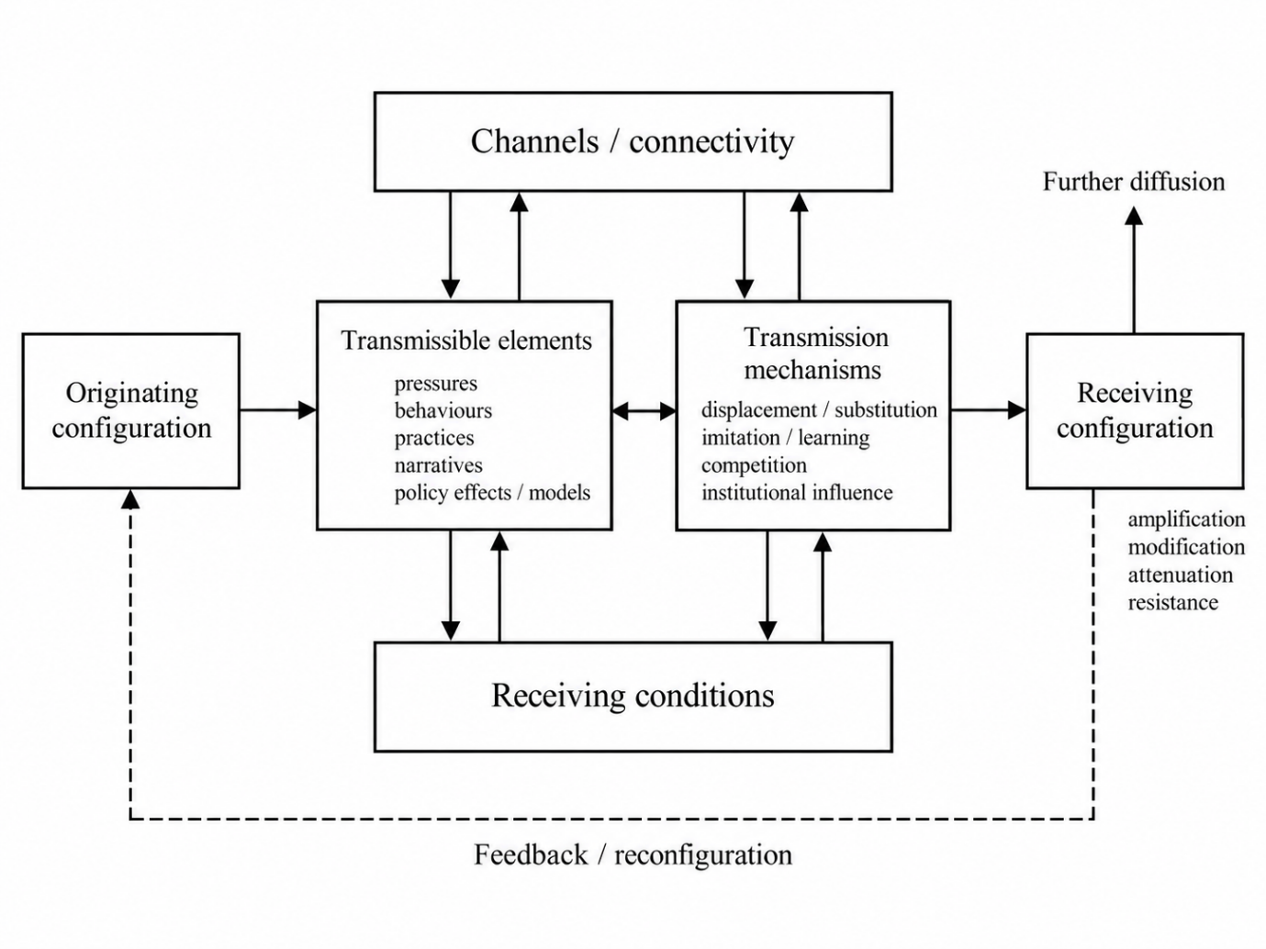
Source: own elaboration.

Diffusion can also generate feedback that reinforces or transforms the configurations from which it originates. For example, short-term rental regulation may redirect accommodation investment and visitor activity towards other neighborhoods or jurisdictions, altering their housing markets, business practices, and institutional responses. Such developments may generate further adaptation and propagation. Importantly, the diffusion of policy effects through displacement and actor adaptation should be distinguished from the diffusion of policy models through institutional learning or imitation. These processes may also redistribute costs towards other communities, raising questions about the systemic and distributional consequences of interventions.

Diffusion in tourism systems can therefore be understood as the relational and context-dependent process through which patterns, behaviors, practices, information, and consequences propagate among interconnected components and settings through identifiable transmission mechanisms, becoming reproduced, modified, amplified, or attenuated according to their interaction with receiving configurations. Its relationship with emergence is recursive: emergent configurations shape what becomes transmissible, while diffusion may reorganize existing relationships and contribute to the generation or transformation of system-level configurations. Empirically, explaining these dynamics requires identifying transmission pathways and mechanisms while distinguishing propagation from common external influences or independent developments.

Integrated Analytical Architecture
Emergence and diffusion can now be integrated into a recursive analytical architecture. Within a focal tourism system, interactions among heterogeneous components generate relatively coherent configurations that condition subsequent action. Because tourism systems are open, the patterns and consequences arising from these configurations may propagate through relational connections and encounter other systems. What arrives is filtered through and transformed by the receiving context, potentially reproducing or modifying an existing configuration, encountering resistance, or contributing to the emergence of a new one. The resulting configuration may then generate further diffusion or feed back into the system from which the process originated.

Figure 2 represents this recursive movement between interaction, configuration, propagation, and contextual transformation.

Figure 2. The emergence–diffusion framework for tourism systems analysis.
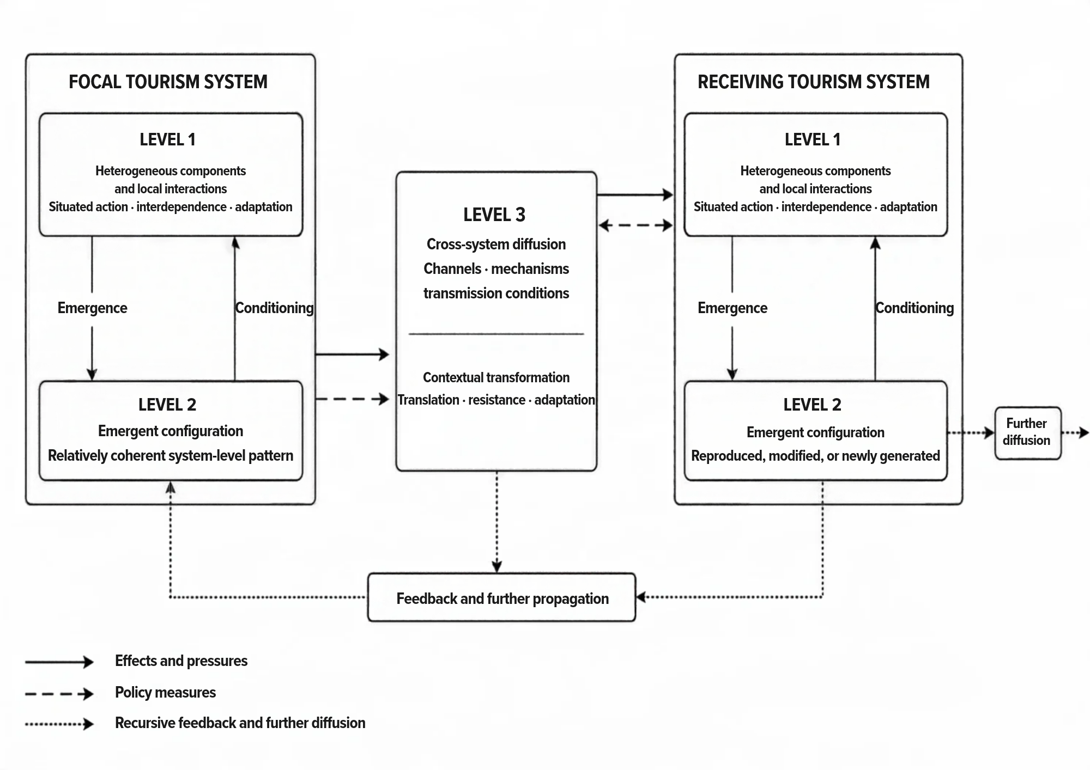Source: own elaboration.

Analysis begins by defining a focal system. This may be a destination, protected area, platform ecosystem, mobility corridor, or policy jurisdiction. Its boundary is analytically constructed and therefore provisional rather than closed. It should encompass the components and relationships directly involved in generating the phenomenon, together with the external connections that materially shape it. Administrative boundaries may be inadequate when mobility, housing markets, labor flows, or ecological processes extend beyond them. An all-inclusive boundary, however, would make explanation unmanageable. Boundary specification must balance analytical focus with systemic openness.

The architecture distinguishes three interdependent levels. These levels are analytical rather than fixed territorial scales, and their composition depends on the phenomenon being explained.

- Level 1: heterogeneous components and local interactions. The relevant components may include individual and collective actors, technological and physical infrastructures, and ecological elements. They differ in their resources, objectives, authority, knowledge, and exposure to tourism processes. Their actions are situated because they respond to partial information and local conditions, yet their outcomes are interdependent through the relationships connecting them. They also adapt to experience, anticipation, and the behavior of others. Heterogeneity is not simply variation around a representative actor; it is one of the conditions through which collective patterns are generated.

- Level 2: emergent configurations. Repeated interaction can generate relatively coherent system-level patterns, such as congestion, housing pressure, destination reputation, market concentration, institutional distrust, or resilience. Feedback may reinforce or constrain their development, while adaptation and selection stabilize some practices and displace others. Thresholds can convert accumulated pressure into discontinuous change. Because these processes are historically conditioned, similar components may produce different configurations, while different combinations of components may generate similar observable outcomes. Once established, an emergent configuration conditions further interaction. For instance, congestion alters mobility decisions, reputation influences demand, and institutional distrust affects how residents interpret policy. This “downward” influence does not require treating the configuration as a causal entity independent of its components. It operates through changes in the constraints, opportunities, expectations, meanings, and relational positions that shape subsequent action.

- Level 3: diffusion dynamics. Analysis then examines what becomes transmissible, the connections through which it propagates, the mechanisms that convert exposure into change, and the configuration that receives it. Propagation depends on the relationship between connectivity, transmissibility, contextual receptivity, and the frictions that inhibit movement. Receiving systems are not passive endpoints: they transform what arrives, may generate a different configuration, and can become sources of subsequent diffusion.

The architecture is dynamic rather than equilibrium-seeking. Recursive cycles may reproduce a configuration, amplify its effects, redirect its development, or shift the system towards another trajectory. The three levels may also be nested. Emergent processes within a firm can contribute to a destination-level configuration, while destinations themselves operate as components of wider regional or transnational systems.

Taken together, the three levels organize systemic explanation as a recursive movement rather than a linear sequence. Analysis begins with situated interactions, examines how they generate a relatively coherent configuration, and identifies how that configuration conditions subsequent action. It then traces which patterns and consequences become transmissible across connections and how they are transformed by the configurations they encounter. The architecture thereby connects how tourism-system outcomes form within systems with how they propagate across systems, without treating either process as the result of independent variable effects.

An important policy implication follows. An intervention may produce a credible effect within a focal setting while also provoking adaptation, displacement, feedback, and diffusion that alter its longer-term consequences. Evaluating tourism policy therefore requires distinguishing among the immediate effect of an intervention, the reorganization of the system in which it is introduced, and the consequences transmitted to connected settings. Operationalizing this architecture requires evidence and methods capable of addressing these different explanatory tasks.

Operationalizing the Emergence–Diffusion Framework
The emergence–diffusion framework does not prescribe a single analytical method. Its operationalization requires defining the explanatory problem and selecting evidence and methods appropriate to the processes under investigation. Causal designs can estimate specified intervention effects, computational models can examine generative mechanisms and feedback, and relational approaches can investigate transmission pathways. Their contribution depends on the explanatory claims they can substantiate rather than the accumulation of techniques.

Analysis begins by defining the phenomenon, focal system, and temporal horizon. System boundaries should encompass the components and relationships involved in generating the phenomenon and the connections through which its consequences may propagate. Because these boundaries are provisional, researchers should justify their selection and reconsider them when relevant relationships extend beyond the initial representation.

At Level 1, analysis identifies the relevant components, their interactions, and the adaptations through which their behavior becomes interdependent. Empirical evidence may be drawn from observations, interviews, surveys, administrative records, mobility data, or digital traces, supported where appropriate by spatial and network analysis. The objective is to establish the relationships and interaction processes potentially generating a collective pattern.

At Level 2, analysis examines whether these interactions generate a coherent system-level configuration, how feedback sustains or transforms it, and how the resulting configuration conditions subsequent action. Longitudinal, comparative, and computational approaches can investigate these processes, but reproducing an observed pattern through simulation does not independently establish that the proposed mechanisms generated the empirical outcome. Establishing emergence requires examining configurational dependence beyond aggregation and assessing alternative explanations.

At Level 3, analysis identifies what propagates, its origin, the transmission channels and mechanisms, and the conditions shaping responses in receiving components or settings. Spatial, network, longitudinal, and process evidence can help trace these relationships. Demonstrating diffusion requires distinguishing transmission from common external influences or independent developments, including examining cases where propagation is attenuated or blocked.

Figure 3 synthesizes these analytical tasks and their integration within an iterative process of systemic explanation and validation.

Figure 3. Operationalization of the emergence–diffusion framework in tourism systems research.
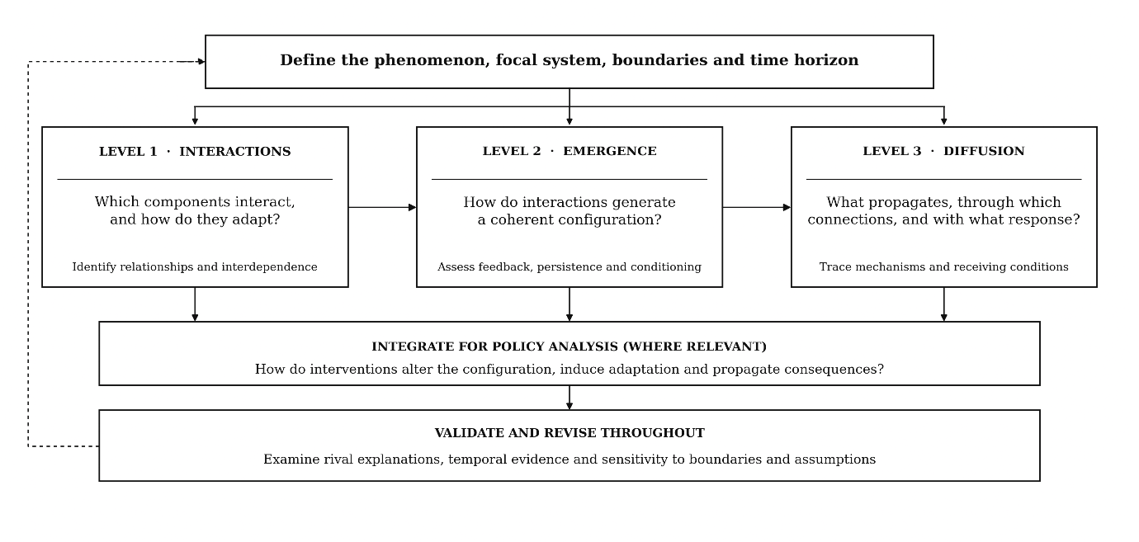Source: own elaboration.

Policy analysis integrates the three levels by examining how interventions modify existing configurations, induce adaptation, and generate consequences that propagate through interconnected components and settings. Where specific intervention effects are estimated, credible causal identification remains essential. More broadly, the framework requires empirical grounding of proposed mechanisms, comparison with alternative explanations, and sensitivity assessment across relevant system boundaries and temporal conditions.

Operationalization is therefore iterative rather than strictly sequential: evidence of emergence or diffusion may require revising the initial system representation or the proposed mechanisms. The objective is not an exhaustive reconstruction of tourism systems, but a defensible explanation of how system-level phenomena emerge, propagate, and transform. The following section illustrates this analytical approach through overtourism.

Overtourism as an Emergent and Diffusive Policy Problem

Overtourism illustrates the relevance of the emergence–diffusion framework because comparable visitor volumes may generate different pressures depending on interactions among tourism actors, markets, infrastructures, communities, and institutions. Understanding these differences requires examining how systemic pressures emerge, reinforce one another, and propagate through interconnected components.

The illustration considers a stylized urban tourism destination comprising interconnected neighborhoods, accommodation markets, transport infrastructures, tourism businesses, residents, digital platforms, and governance institutions. Its analytical boundaries follow functional relationships rather than administrative jurisdictions, while its temporal scope encompasses the development and transformation of tourism pressures and policy responses.

The analysis examines how an overtourism configuration emerges, how its pressures and consequences diffuse, and how both processes inform policy intervention and evaluation. As a conceptual illustration rather than an empirical application, it demonstrates the framework's explanatory potential and methodological requirements.

Overtourism as an Emergent Configuration
Overtourism is frequently approached as a problem of excessive demand relative to destination carrying capacity. Although visitor volume is relevant, it cannot adequately explain why comparable tourism intensities generate different outcomes across destinations or neighborhoods. Within the urban destination considered here, tourism pressure depends on how visitor activity interacts with accommodation markets, spatial organization, infrastructure, environmental conditions, resident expectations, and governance arrangements.

From an emergence perspective, overtourism is understood as a historically contingent system-level configuration generated through the interdependence of these elements, rather than simply the aggregation of individual tourism impacts. The analytical implications of this reconceptualization are illustrated in Figure 4. The shift from an indicator-centered towards an emergence-based explanation involves moving beyond the identification of factors associated with tourism pressure to investigating how their interactions generate, sustain, and transform a system-level configuration.

Figure 4. Reframing overtourism through the emergence paradigm.
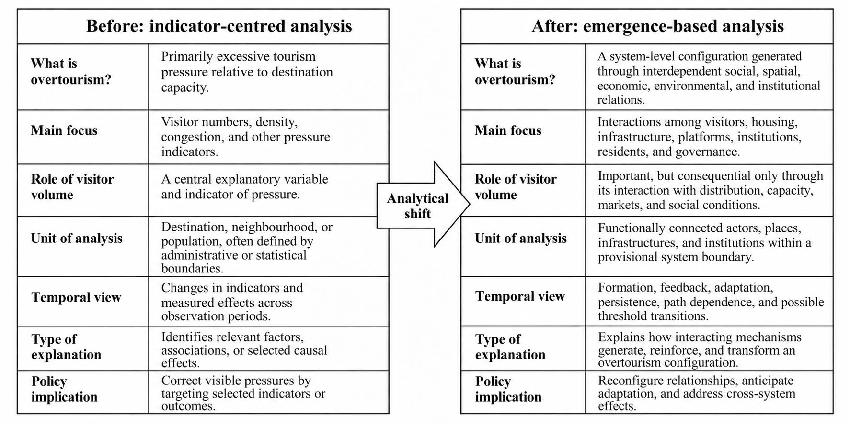
Source: own elaboration.

Applying the framework begins by identifying the relevant components and interactions (Level 1). Visitor choices, digital visibility, and tourism investment may reinforce spatial concentration, attracting further demand and commercial activity. Tourism-related profitability may simultaneously encourage accommodation conversion, altering housing accessibility and neighborhood composition. These processes interact with infrastructure pressures, while residents interpret their consequences through perceptions of fairness and institutional trust. The analytical task is to establish how these relationships and behavioral adaptations become interdependent.

The subsequent task is to explain how these interactions generate an emergent configuration (Level 2). Spatial concentration, accommodation conversion, and infrastructure pressures may reinforce one another, stimulating resident mobilization and regulatory responses that subsequently reshape investment and visitor behavior. Through such feedback, initially localized pressures may develop into a persistent configuration that conditions subsequent action. Overtourism is therefore explained through the organization and reinforcement of these processes rather than their independent effects.

Establishing emergence requires evidence of configurational dependence beyond aggregation. Longitudinal records of visitor concentration, accommodation conversion, infrastructure utilization, and resident responses, combined with spatial and relational evidence, could help reconstruct the underlying mechanisms. Comparisons between neighborhoods with similar visitor volumes but different interaction patterns could assess their explanatory significance. Process analysis and computational modelling may further investigate whether the proposed mechanisms can generate the observed patterns, although their empirical relevance must be assessed against additive and alternative explanations.

Identifying interacting pressures does not, by itself, demonstrate emergence; their configurational dependence, temporal development, and systemic consequences require empirical substantiation. Moreover, overtourism remains a partly contested normative category: identifying an emergent configuration does not determine which consequences are socially acceptable or whose interests should define destination performance. This analysis establishes the basis for examining how tourism pressures and responses subsequently propagate through the destination.

Overtourism as a Diffusive Phenomenon
While emergence explains how overtourism develops as a system-level configuration, diffusion examines how tourism pressures, behaviors, investments, information, and institutional responses propagate through interconnected destination components. Such processes may originate in different neighbourhoods, markets, platforms, or institutions and follow multiple relational pathways rather than a predetermined geographical direction. The analytical contribution of diffusion lies in explaining how these influences are transmitted, amplified, attenuated, or transformed by the configurations they encounter.

Figure 5 illustrates three complementary mechanisms through which tourism-related pressures, behaviors, and responses may propagate within a destination: spatial displacement and market substitution, informational and behavioral diffusion, and social and institutional diffusion. These mechanisms connect different components of the tourism system, while the characteristics of receiving neighborhoods, actors, and institutions condition whether transmitted influences are amplified, modified, or attenuated.

Figure 5. Reframing overtourism through the diffusion perspective.
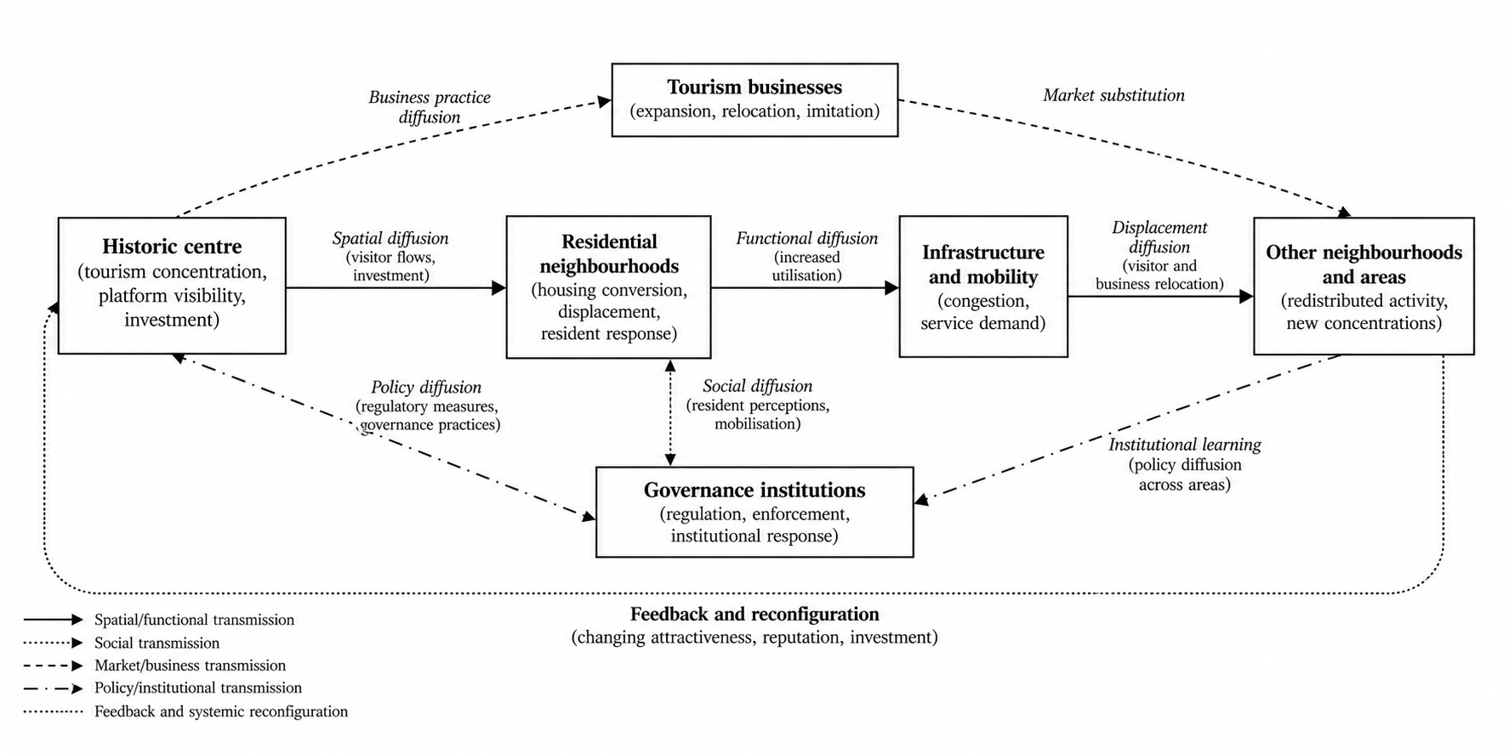
Source: own elaboration.

Applying the diffusion perspective requires identifying what propagates, through which connections, and by what mechanisms (Level 3). Spatial displacement and market substitution may redirect visitor activity, investment, and tourism businesses between interconnected neighborhoods, altering housing conditions, commercial activity, and infrastructure utilization. The consequences depend on the receiving areas' capacities, market structures, and residential conditions, which may amplify, modify, or attenuate the transmitted pressures.

Informational, behavioral, and institutional diffusion operate through complementary pathways. Digital platforms and social networks may influence visitor preferences and encourage business imitation, while resident networks transmit experiences and interpretations of tourism pressures, potentially stimulating collective mobilization and institutional responses. These processes may reinforce existing concentrations or extend pressures to other components of the destination, depending on actors' resources, expectations, and institutional conditions.

Empirically, establishing diffusion requires identifying the transmitted element, its origin, transmission pathway, and mechanism, while distinguishing propagation from common external influences or independent developments. Longitudinal records of visitor movements, accommodation activity, investment, and resident responses, combined with spatial, network, and process evidence, could help reconstruct these mechanisms. Comparisons between connected areas experiencing different outcomes may reveal the conditions under which diffusion is amplified, transformed, or contained.

The diffusion perspective thus explains how tourism pressures and responses propagate through interconnected destination components and modify receiving configurations. These processes may also extend across destinations. Combined with emergence, diffusion helps explain how policy interventions can modify existing configurations while generating adaptive responses and consequences elsewhere in the tourism system.

Emergence-Diffusion in Tourism Policymaking
Integrating emergence and diffusion extends tourism policy analysis beyond estimating intervention effects towards understanding how policies modify the configurations generating systemic problems and how their consequences propagate through interconnected components. Policy interventions are therefore examined as part of the evolving systems they seek to govern, rather than as external actions producing isolated outcomes.

Consider short-term rental regulation in the urban tourism system examined above. Housing pressure and resident opposition may emerge through reinforcing interactions among tourism demand, platform visibility, property investment, accommodation conversion, and institutional responses. Restrictions on short-term rental licenses intervene in this configuration by modifying actors' incentives and opportunities. A credible causal evaluation could estimate their effects on accommodation supply, rental availability, or housing prices. However, systemic analysis additionally examines whether the intervention changes the relationships generating housing pressure as property owners, investors, platforms, and visitors adapt their behavior.

Diffusion analysis traces how these adaptations and their consequences propagate through the destination. Accommodation investment and visitor activity may shift towards other neighborhoods through displacement and substitution, while information, business practices, and institutional responses circulate through market, digital, and governance networks. Receiving conditions, including housing markets, infrastructure, and institutional capacities, determine whether transmitted pressures are amplified, modified, or attenuated. Consequences may also extend beyond the destination, while policy models may diffuse separately through institutional learning or imitation.

The central evaluative question is therefore whether an intervention reduces the pressures sustaining an overtourism configuration or primarily redistributes them. An illustrative investigation could combine causal estimates of selected outcomes with longitudinal, spatial, and network evidence to trace adaptation and propagation. Qualitative process analysis could clarify the mechanisms involved, while computational modelling may examine whether proposed interactions and feedback can generate observed configurations and explore alternative policy arrangements. These approaches require empirical grounding and comparison with competing explanations, including common external influences and cases where adaptation or diffusion does not occur.

Table 1 summarizes the complementary questions addressed by bounded causal evaluation and emergence–diffusion analysis.

Table 1. Complementary perspectives on overtourism policy evaluation.

Evaluation dimension | Bounded causal evaluation | Emergence–diffusion analysis
Intervention effects | What effect does a specified policy have on defined outcomes? | How does the intervention modify relationships sustaining the system configuration?
Behavioral adaptation | How do specified actors respond to the intervention? | How do interdependent adaptations reorganize collective behavior and feedback?
Temporal dynamics | How do effects develop over the observation period? | Do feedback and accumulation reinforce, weaken, or transform the configuration?
Diffusion and spillovers | What effects occur among specified connected units or populations? | What propagates, through which mechanisms, and how do receiving contexts transform it?
Structural consequences | What changes occur in the outcomes or mechanisms being evaluated? | Does the intervention alter the configuration generating the original problem?
Distribution and context | For whom, and under what conditions, does the intervention produce effects? | How are consequences redistributed across connected components, places, and social groups?
Source: own elaboration.

These perspectives are complementary. Contemporary causal inference can address heterogeneous effects, adaptation, interference, and dynamic interventions when supported by appropriate research designs. The additional contribution of emergence–diffusion analysis lies in connecting such evidence to the generation and transformation of system-level configurations. Its explanatory value must nevertheless be assessed through empirical validation, alternative mechanisms, and comparison with simpler explanations.

For policymaking, this integrated perspective supports anticipatory and adaptive governance by examining whether interventions transform underlying systemic pressures, generate new vulnerabilities, or redistribute burdens towards other communities. Policy effectiveness consequently depends not only on achieving targeted outcomes but also on understanding the configurations that interventions sustain or transform and the distribution of their consequences across the wider tourism system.

Discussion

This section examines the framework’s contributions and explanatory advantages, its conditions of applicability, and its implications for tourism research and policymaking, before addressing limitations and priorities for further development.

Analytical Contributions
The principal contribution of the emergence–diffusion framework lies in integrating three explanatory problems that tourism research frequently addresses separately: the generation of system-level configurations through interaction, the conditioning of subsequent behavior by those configurations, and the propagation and transformation of their consequences through connected components and settings. Their integration enables tourism phenomena to be examined as historically evolving and recursively interconnected processes rather than as collections of independent variables or isolated causal relationships.

This approach extends, rather than replaces, conventional causal explanation. Experimental and quasi-experimental designs can establish the effects of specified interventions under defensible identification assumptions, including heterogeneous, dynamic, and spillover effects when appropriately designed. However, estimating an intervention effect does not necessarily explain how the configuration generating the original problem developed, how the intervention reorganizes its constituent relationships, or how these changes contribute to subsequent systemic transformation. Emergence–diffusion analysis broadens the explanatory object by connecting bounded causal effects with the generative and relational processes within which they occur.

The proposed framework also builds upon established complexity-oriented approaches rather than introducing an entirely new set of analytical methods. Agent-based modelling can investigate how interaction rules generate collective patterns; system dynamics can represent accumulation and feedback; network analysis can examine relational structures and propagation; and longitudinal or process approaches can reconstruct temporal development and institutional change. These capabilities are not unique to emergence–diffusion analysis. Its distinctive contribution lies in organizing them around a shared explanatory architecture that explicitly connects system formation, configurational conditioning, and transmission, while requiring evidence appropriate to each inferential task.

This integration potentially offers several analytical advantages. It directs attention towards configurations that cannot be adequately explained through aggregation, identifies how previously generated conditions constrain or enable subsequent action, and traces how pressures and responses propagate through relationships that may cross functional or administrative boundaries. In policymaking, it allows the evaluation of an intervention to extend beyond its immediate effects towards examining whether the underlying configuration is reproduced, modified, or transformed and whether consequences are attenuated or redistributed elsewhere. The overtourism illustration shows how such questions can reveal mechanisms that remain obscured when visitor volumes, housing pressures, resident responses, and policy outcomes are examined independently.

These advantages should nevertheless be treated as propositions requiring empirical assessment rather than presumed methodological superiority. The framework will provide additional explanatory value only when its integrated representation identifies consequential mechanisms, explains observed configurations and trajectories, or reveals systemic consequences more effectively than plausible alternative approaches. Its contribution therefore rests not on invoking complexity itself, but on developing explanations whose mechanisms, assumptions, and empirical implications can be examined and compared.

Scope Conditions and Analytical Boundaries
The emergence–diffusion framework is particularly relevant when tourism phenomena exhibit substantial interdependence, heterogeneous adaptation, reinforcing or constraining feedback, historical contingency, and propagation through interconnected components. Its analytical value increases when the outcomes of individual actions depend on their relational organization, when interventions modify the conditions under which actors respond, or when consequences extend beyond the setting in which they originate. These characteristics are common in tourism systems, but they are not equally important in every research problem.

Not every investigation therefore requires a comprehensive systemic representation. A well-defined question concerning the short-term effect of a relatively stable intervention, involving approximately independent units and limited spillovers, may be adequately addressed through conventional causal inference. Similarly, aggregate indicators may sufficiently characterize certain outcomes without invoking emergence. Analytical complexity is justified only when it contributes to explaining mechanisms or consequences that simpler approaches leave insufficiently understood. Table 2 summarizes the conditions under which different explanatory emphases become relevant.

Table 2. Scope conditions for emergence–diffusion analysis in tourism research.

Research condition | Appropriate analytical emphasis | Emergence–diffusion contribution
Stable intervention, bounded units, and limited spillovers | Experimental or quasi-experimental causal estimation | Adds systemic context where relevant
Heterogeneous interdependent actors | Interaction and relational analysis | Explains emergent configurations
Feedback, delays, or threshold | Longitudinal and dynamic modelling | Explains persistence and transformation
Propagation across connected components | Spatial, network, and diffusion analysis | Identifies transmission and contextual transformation
Interacting policies and adaptive response | Integrated causal and process analysis | Explains policy-induced reconfiguration
Contested outcomes and unequal impacts | Distributional and participatory analysis | Identifies whose interests and outcomes matter
Source: own elaboration.

Several analytical boundaries follow from these distinctions. First, emergence should not be inferred merely from complexity, nonlinearity, or the coexistence of interacting factors; its explanatory relevance depends on demonstrating configurational dependence beyond aggregation or isolated component effects. Second, diffusion requires evidence of a transmissible element, a relational pathway, and a mechanism linking exposure to subsequent change. Similar developments across connected settings may instead reflect common external influences or independent responses. Third, system boundaries should remain sufficiently focused to support investigation while incorporating the connections that materially affect the phenomenon. Their specification must be theoretically justified and open to empirical reconsideration.

The framework consequently does not prescribe methodological maximalism. An appropriate representation is one that captures the relationships and processes necessary to answer the research question without introducing unnecessary complexity. The relevant criterion is explanatory adequacy, not the number of variables, actors, analytical levels, or methods incorporated.

Research and Policy Implications
For tourism research, the framework encourages analytical designs in which methods are selected according to their explanatory functions and connected through explicit inferential reasoning. Investigations should identify relevant system boundaries, establish the mechanisms generating and sustaining emergent configurations, and trace their consequences through interconnected components. Causal estimation, computational modelling, network analysis, and qualitative or longitudinal approaches can provide complementary evidence, but their combination must be justified by the research question rather than methodological accumulation.

This orientation also supports more cumulative systems research through transparent reporting of assumptions concerning actors, interactions, relational structures, temporal scales, system boundaries, and mechanisms. Computational explanations require empirical grounding, comparison with alternative mechanisms, and validation against observations beyond those used for model calibration. Similarly, diffusion claims require evidence distinguishing transmission from common causes or parallel developments. Such practices would facilitate comparisons across tourism systems without assuming that similar outcomes necessarily arise through identical mechanisms.

For tourism policymaking, the framework supports anticipatory and adaptive governance. Rather than relying exclusively on aggregate indicators, authorities can examine evolving relationships, concentrations, vulnerabilities, and feedback that may generate undesirable configurations. Accommodation conversion, infrastructure pressures, digital visibility, resident mobilization, and relational connectivity may provide relevant signals when theoretically and empirically grounded. Anticipation should nevertheless focus on plausible systemic trajectories rather than predetermined predictions.

The framework also broadens policy evaluation and coordination. Housing regulation, tourism promotion, mobility management, environmental protection, and platform governance may generate interacting or redistributive consequences. Interventions effective within one jurisdiction may leave underlying mechanisms unchanged or transfer pressures elsewhere. Systemic evaluation therefore requires monitoring behavioral adaptations, changes in generative configurations, and diffusion pathways, alongside procedures for revising assumptions and adjusting interventions as evidence develops.

These implications also have normative dimensions. Tourism systems involve unequal distributions of ownership, authority, resources, and exposure to benefits and costs. Apparently stable or resilient configurations may reproduce exclusion, environmental degradation, or unequal political influence, while successful interventions may displace burdens towards less powerful communities. Emergence–diffusion analysis should therefore clarify whose interests define system performance, how inequalities shape systemic processes, and how affected stakeholders participate in determining acceptable outcomes. Participation, transparency, and accountability remain integral to evaluating the consequences of tourism governance.

Limitations and Future Research
The emergence–diffusion framework remains a conceptual and methodological proposal whose empirical explanatory value has yet to be established. Its integrative scope creates risks of conceptual ambiguity, retrospective interpretation, and excessive analytical complexity. Without sufficiently precise criteria, emergence, feedback, and diffusion could become descriptive labels rather than discriminating explanatory concepts. Future research must therefore examine whether the framework generates empirically testable explanations that improve upon existing approaches.

A central limitation concerns the empirical identification of emergence. Distinguishing configurations generated through interdependent relationships from patterns attributable to aggregation or independent component effects remains methodologically challenging. Moreover, identifying feedback or reproducing an observed pattern computationally does not establish that the proposed mechanisms operated in the empirical system. Longitudinal, comparative, and computational investigations could help address these difficulties by examining configurational dependence, temporal persistence, and alternative generative mechanisms.

Diffusion presents related identification challenges. Correlated developments across connected components do not necessarily indicate propagation, while transmission mechanisms and receiving conditions may be difficult to observe directly. The selection of system boundaries and temporal horizons further influences which relationships become visible. Future studies could combine spatial, network, longitudinal, and qualitative evidence to distinguish transmission from common external influences, investigate contextual variation, and assess the robustness of diffusion explanations across alternative system representations.

A further limitation is that the framework's comparative analytical advantage remains unproven. Its broader explanatory scope may increase data requirements and model complexity without necessarily improving understanding. Comparative applications should therefore assess whether emergence–diffusion analysis explains configurations, mechanisms, temporal developments, or systemic consequences that simpler causal, statistical, or complexity-oriented approaches cannot adequately capture. Such comparisons are essential for establishing when the framework adds explanatory value and when less demanding approaches remain sufficient.

Practical application also faces limitations arising from fragmented data, institutional boundaries, uneven analytical capacities, and the difficulty of evaluating interventions within evolving systems. Data-intensive approaches introduce additional concerns regarding privacy, representational bias, transparency, and data governance. Future research could investigate these constraints through empirical policy applications that combine multiple evidence sources while explicitly addressing institutional feasibility, distributional consequences, and stakeholder participation.

These limitations underscore the need for progressive theoretical specification, empirical validation, and comparative assessment. The framework's contribution will depend not on its capacity to encompass every dimension of tourism-system complexity, but on whether it produces more precise and defensible explanations of emergence, diffusion, and transformation, and identifies the conditions under which these explanations improve tourism research and policymaking.

Conclusion

Tourism research increasingly recognizes the complex, adaptive, and interconnected nature of tourism systems, yet established analytical approaches do not always explain how interactions generate system-level configurations, how these configurations condition subsequent behavior, or how their consequences propagate and transform. This paper addresses these explanatory challenges by proposing an emergence–diffusion framework that integrates the relational and temporal processes through which tourism systems evolve.

Emergence explains the generation and persistence of configurations beyond aggregation, while diffusion explains the propagation and contextual transformation of pressures, behaviors, practices, and consequences. Their recursive interaction provides a basis for understanding systemic formation, continuity, and change.

The framework's principal contribution lies in organizing complementary analytical approaches around these interconnected processes rather than introducing new techniques. By connecting causal inference, computational modelling, relational analysis, and longitudinal evidence to specific explanatory requirements, it offers a basis for investigating phenomena that isolated analyses may not adequately capture.

The overtourism illustration demonstrates how this perspective can illuminate the mechanisms generating systemic pressures, their propagation through connected components, and the adaptive consequences of policy interventions. For policymaking, it supports evaluation that considers not only targeted outcomes but also changes in underlying configurations, the redistribution of pressures, and their distributional implications.

As a conceptual and methodological proposal, the framework's comparative explanatory advantages remain to be established empirically. Its contribution will depend on identifying emergent configurations and diffusion mechanisms through defensible evidence and demonstrating their explanatory value against alternative approaches. Rather than replacing established methods, the emergence–diffusion framework seeks to extend their capacity to explain how tourism systems generate, propagate, and transform systemic phenomena, thereby supporting more comprehensive research and more anticipatory and adaptive governance.

References

Ali, F., Koseoglu, M. A., Okumus, F., Putra, E. D., Yildiz, M., & Dogan, I. C. (2021). Is lodging research suffering from methods bias? An assessment of published research during 1990-2016. Journal of Hospitality and Tourism Technology, 12(3), 423–438. https://doi.org/10.1108/JHTT-06-2020-0150
Anderson, P. W. (1972). More Is Different. Science, 177(4047), 393–396. https://doi.org/10.1126/science.177.4047.393
Ansari, S. M., Fiss, P. C., & Zajac, E. J. (2010). Made to fit: How practices vary as they diffuse. Academy of Management Review, 35(1), 67–92.
Baggio, R. (2008). Symptoms of complexity in a tourism system. Tourism Analysis, 13(1), 1–31.
Baggio, R., Scott, N., & Cooper, C. (2010). Improving tourism destination governance: a complexity science approach. Tourism Review, 65(4), 51–60.
Barbour, J. B. (2017). Micro/meso/macrolevels of analysis. The International Encyclopedia of Organizational Communication, 1–15.
Bedau, M. (2002). Downward causation and the autonomy of weak emergence. Principia: An International Journal of Epistemology, 6(1), 5–50.
Bollen, K. A., & Pearl, J. (2013). Eight myths about causality and structural equation models. In Handbook of causal analysis for social research (pp. 301–328). Springer.
Centola, D., & Macy, M. (2007). Complex contagions and the weakness of long ties. American Journal of Sociology, 113(3), 702–734.
Chalmers, D. J. (2006). Strong and weak emergence. The Re-Emergence of Emergence, 675, 244–256.
Cox, D. R., & Wermuth, N. (2004). Causality: a statistical view. International Statistical Review, 72(3), 285–305.
Farrell, B. H., & Twining-Ward, L. (2004). Reconceptualizing tourism. Annals of Tourism Research, 31(2), 274–295.
Green, D. G. (2023). Emergence in complex networks of simple agents. Journal of Economic Interaction and Coordination, 18(3), 419–462.
Hawe, P., Shiell, A., & Riley, T. (2009). Theorising interventions as events in systems. American Journal of Community Psychology, 43(3), 267–276.
Hernán, M. A., & Robins, J. M. (2026). Causal inference. CRC Boca Raton, FL.
Holland, J. H. (1998). Emergence: From chaos to order. Oxford University Press.
Hudgens, M. G., & Halloran, M. E. (2008). Toward causal inference with interference. Journal of the American Statistical Association, 103(482), 832–842.
Kleinberg, J., Ludwig, J., Mullainathan, S., & Obermeyer, Z. (2015). Prediction policy problems. American Economic Review, 105(5), 491–495.
Lazer, D., Kennedy, R., King, G., & Vespignani, A. (2014). The parable of Google Flu: traps in big data analysis. Science, 343(6176), 1203–1205.
McKercher, B. (1999). A chaos approach to tourism. Tourism Management, 20(4), 425–434.
Meng, X.-L. (2018). Statistical paradises and paradoxes in big data (I): Law of large populations, big data paradox, and the 2016 US presidential election.
Mikulić, J., & Ryan, C. (2018). Reflective versus formative confusion in SEM based tourism research: A critical comment. Tourism Management, 68, 465–469.
Mullainathan, S., & Spiess, J. (2017). Machine learning: An applied econometric approach. Journal of Economic Perspectives, 31(2), 87–106.
Nunkoo, Robin, Ramkissoon, Haywantee, & Gursoy, Dogan. (2013). Use of Structural Equation Modeling in Tourism Research: Past, Present, and Future. Journal of Travel Research, 52(6), 759–771. https://doi.org/10.1177/0047287513478503
Pearl, J. (2009). Causality: Models, Reasoning, and Inference (2nd ed.). Cambridge University Press.
Rogers, E. M., Singhal, A., & Quinlan, M. M. (2014). Diffusion of innovations. In An integrated approach to communication theory and research (pp. 432–448). Routledge.
Rosas, F. E., Mediano, P. A. M., Jensen, H. J., Seth, A. K., Barrett, A. B., Carhart-Harris, R. L., & Bor, D. (2020). Reconciling emergences: An information-theoretic approach to identify causal emergence in multivariate data. PLoS Computational Biology, 16(12), e1008289.
Shipan, C. R., & Volden, C. (2008). The mechanisms of policy diffusion. American Journal of Political Science, 52(4), 840–857.
Shmueli, G. (2010). To explain or to predict? Statistical Science, 289–310.
Shojaie, A., & Fox, E. B. (2022). Granger causality: A review and recent advances. Annual Review of Statistics and Its Application, 9, 289–319.
Skivington, K., Matthews, L., Simpson, S. A., Craig, P., Baird, J., Blazeby, J. M., Boyd, K. A., Craig, N., French, D. P., & McIntosh, E. (2021). A new framework for developing and evaluating complex interventions: update of Medical Research Council guidance. Bmj, 374.
Song, H., Qiu, R. T. R., & Park, J. (2019). A review of research on tourism demand forecasting: Launching the Annals of Tourism Research Curated Collection on tourism demand forecasting. Annals of Tourism Research, 75, 338–362. https://doi.org/https://doi.org/10.1016/j.annals.2018.12.001

